CONEXIÓN

**En el caso de ánodo común:**

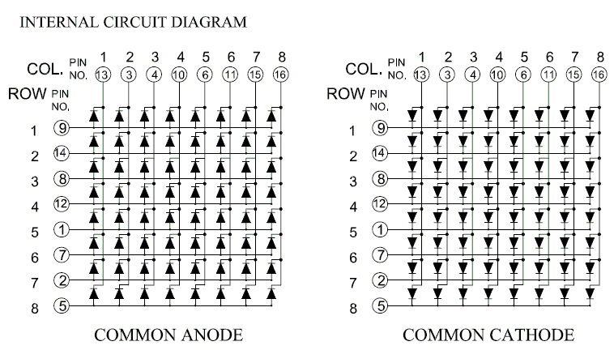

|  |  |  |  |  |  |  |  |  |  |  |  |  |  |  |  |  |
| --- | --- | --- | --- | --- | --- | --- | --- | --- | --- | --- | --- | --- | --- | --- | --- | --- |
| MATRIZ | 1 | 2 | 6 | 11 | 7 | 13 | 14 | 4 | 12 | 15 | 10 | 16 | 5 | 9 | 3 | 8 |
| ARDUINO | 2 | 3 | 4 | 5 | 6 | 7 | 8 | 9 | 19 | 11 | 12 | 13 | A0 | A1 | A2 | A3 |

**En el caso de cátodo común:**

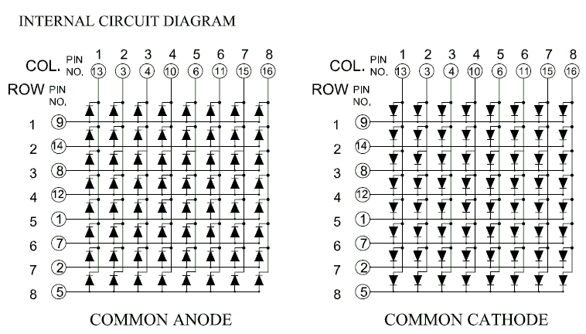

|  |  |  |  |  |  |  |  |  |  |  |  |  |  |  |  |  |
| --- | --- | --- | --- | --- | --- | --- | --- | --- | --- | --- | --- | --- | --- | --- | --- | --- |
| MATRIZ | 13 | 3 | 4 | 10 | 6 | 11 | 15 | 16 | 9 | 14 | 8 | 12 | 1 | 7 | 2 | 5 |
| ARDUINO | 2 | 3 | 4 | 5 | 6 | 7 | 8 | 9 | 10 | 11 | 12 | 13 | A0 | A1 | A2 | A3 |

SUSCRIBETE:

<https://www.youtube.com/channel/UCBwN7Z5LWQAJ_6ueSEzDtGQ?view_as=subscriber>

CREDITOS:

ABC proyectos electrónicos

https://www.prometec.net/matriz-led-8x8/